Single Vehicle VRPPDTW Problem Based on Stochastic Travel Time

-------------------------------------------------------------------------------------------------------------------

User Guide

December 2020

contenT

1 Problem Statement 3

1.1 Vehicle Routing Problem(VRP) 3

1.2 Vehicle Routing Problem with Time Window(VRPTW) 3

1.3 Vehicle Routing Problem with Pickup and Delivery(VRPPD) 3

1.4 Vehicle Routing Problem with Pickup and Delivery with Time Window(VRPPDTW) 3

2 Underlying Network Structure 4

2.1 Nodes of VRPPDTW Network 4

2.2 Arcs of VRPPDTW Network 4

2.3 States Transition 5

3 Methodology 8

4 Quick Run 9

5 Input and Output 10

5.1 Input 10

5.2 Output 11

6 Tests 14

# 1 Problem Statement

This algorithm is suitable for solving the single-vehicle VRP problem with pickup and delivery with time window (VRPPDTW) based on historical daily travel time data, using Lagrangian relaxation algorithm and dynamic programming algorithm. The model and algorithm are sepcified in my thesis, which could be cited after July 2021.

**Input:** physical network, passenger information(original, destination and time window)and vehicle information(capacity and time window)

**Output:** space-time path of vehicle and state transition

**Constraints:** time window constraints, vehicle capacity constraints, passenger demands constraints and unique physical path constraints

**Objective:** the least-expected cost

## 1.1 Vehicle Routing Problem(VRP)

The VRP problem was first proposed by G. Dantzig and J. Ramser in 1959. The traditional VRP problem can be summarized as: a fleet provides services for a certain number of passengers, and we need to find a series of vehicle routes( Starting from the parking lot, returning to the parking lot after completing the service for passengers) under vehicle capacity constraints, to achieve the objective of shortest distance, or the least cost, or the least travel time.

The actual vehicle routing problems include distribution, bus routing, letter and newspaper delivery, air and railway schedule arrangements, etc.

## 1.2 Vehicle Routing Problem with Time Window(VRPTW)

When all passenger services need to be carried out in a given time interval (called time window), it is a VRP problem with a time window(VRPTW), an extension of the general VRP problem. The time window can be regarded as a soft constraint or a hard constraint. When all services must be performed within a given time window, it is a hard constraint; when a penalty value is imposed on services outside the time window, it is a soft constraint.

## 1.3 Vehicle Routing Problem with Pickup and Delivery(VRPPD)

The traditional VRP problem only considers a single process of "gathering" or "distributing" people or goods. During the course of a vehicle, the change in passenger/cargo volume is monotonous. The VRP problem with pickup and delivery (VRPPD) is a collection of pickup and delivery services. It needs to be carried out at the designated starting point and endpoint according to customers' needs. It also considers the pickup and drop-off of passengers or the collection and distribution of goods in route planning.

## 1.4 Vehicle Routing Problem with Pickup and Delivery with Time Window(VRPPDTW)

The VRPPDTW is a problem that all passengers or goods need to be picked up within a specified time window and delivered to the destination within another fixed time window. At the same time, each vehicle also has the time window constraints for leaving and returning to the warehouse and capacity constraints.

# 2 Underlying Network Structure

## 2.1 Nodes of VRPPDTW Network

In the VRPPDTW network, there are physical nodes, passenger pickup and delivery nodes, and vehicle station nodes. Take a six-node physical network of case 1 in **Figure1** as an example. The original of passenger 1 is at node 2 and the destination is at node 6; the original of passenger 2 is at node 5, and the destination is at node 3. There is a vehicle at the warehouse of node 4 distributed to serve the two passengers, and the vehicle finally returns to the warehouse of node 1. In order to distinguish between physical nodes, passenger pickup and delivery nodes, and vehicle station nodes, this paper respectively adds virtual nodes $o_{1}$ (the original of passenger 1) and $d_{1}$ (the destination of passenger 1) at node 2 and node 6, $o_{2}$ (the original of passenger 2) and $d_{2}$ (the destination of passenger 2) at node 5 and node 3, $o_{1}^{'}$ (the departure warehouse of vehicle 1) and $d_{1}^{'}$ (the return warehouse of vehicle 1) at node 4 and node 1.

The time window is indicated in parentheses next to the virtual node. For example, passenger 1 must be picked up at the virtual node $o_{1}$ within the time window [5,7], and delivered at the virtual node $d_{1}$ within [9,12]; passenger 2 must be picked up at the virtual node $o_{2}$ within [8,10], and delivered at the virtual node $d_{2}$ within the time window [14,19]. Similarly, the vehicle must depart from the warehouse $o_{1}^{'}$ at t=1 and return to the warehouse $d_{1}^{'}$ within [1,30].

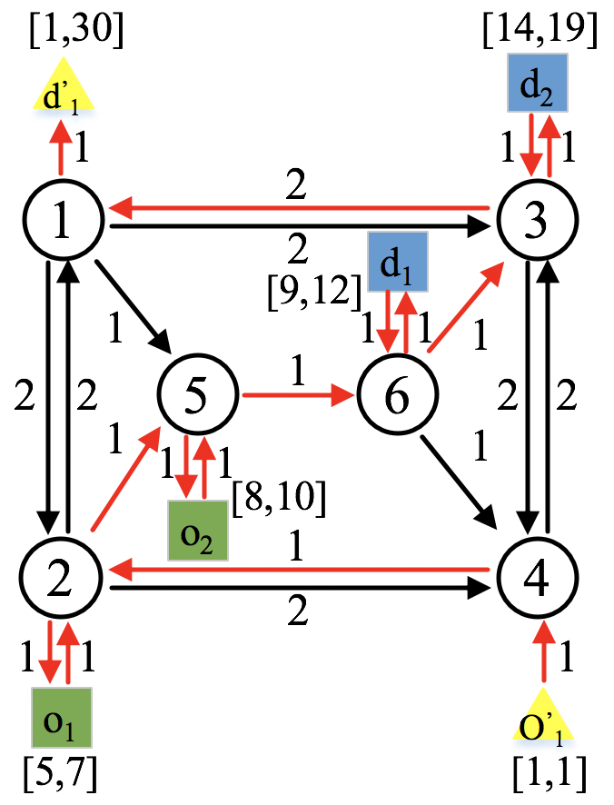

**Figure 1 Six-node network with virtual nodes**

## 2.2 Arcs of VRPPDTW Network

According to different types of nodes, arcs can also be divided into three categories: transportation arcs, service arcs and waiting arcs, shown in **Figure 2**.

1. Transportation arcs

A transportation arc connects two adjacent transportation nodes, which means that the vehicle is travelling on the corresponding physical link. The state of passengers and vehicles passing through the transportation arc remains unchanged.

1. Service arcs

Service arc can be pickup arc or delivery arc, which means that passenger gets on or off the vehicle. Two nodes linked by the service arc are the receiving node (the original of the passenger) and the sending node (the destination of the passenger). Obviously, the state of the vehicle and passengers will change due to the behaviour of getting on and off the vehicle.

1. Waiting arcs

Waiting arcs indicate that the vehicle stops and waits to satisfy the time window constraints. For example, the green horizontal line in **Figure 2** indicates that the vehicle at $o_{1}$ is waiting for passenger 1. Once passenger 1 approaches the location, the vehicle can pick him/her up immediately.

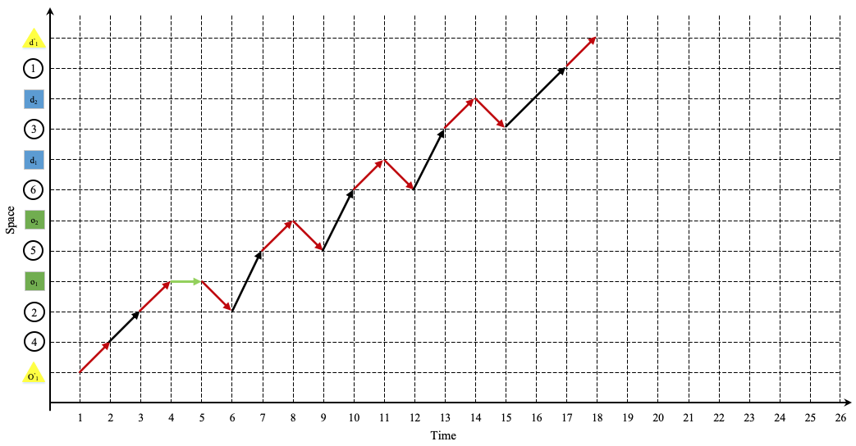

**Figure 2 Space-time arcs**

## 2.3 States Transition

1. States representation

In the time-space-state network constructed in this paper, the state $w$ refers to the cumulative service times of passengers. The passenger state $w$ can also be expressed as a vector [ $π_{1} π_{2}…π_{p}…π_{P}]$ with $|P|$ elements, where the value of $π_{p}$ can be 0, or 1, or 2, respectively indicating that the vehicle serves passengers 0 times (unserved passengers), or the vehicle serves Passengers 1 time (the vehicle picks up passengers), or the vehicle serves passengers 2 times (the vehicle drops passengers). As shown in **Figure 3**, in order to facilitate the description of the state transition, we introduce the following equivalent symbol system for the cumulative service states of passengers: if the vehicle carries passenger $p$, then the $p$-th element of state fills the passenger ID; otherwise, it will be filled with a dotted line. **Figure 3** shows the state of carpooling: [$_ _ _]$ (no passengers are served), [$p_{1} _ _]$ ( passenger 1 is picked up), [$p_{1} p_{2} _]$ (passenger 2 is picked up), [$_ p_{2}_]$ (passenger 1 is delivered) and [$_ _ _]$ (passenger 2 is delivered). The accumulated service states of passengers corresponding to these states are shown in **Table 1**.

**Figure 3** **Equivalent symbol of states transition**

**Table 1** **Accumulated service states of passengers and equivalent symbol**

|  |  |
| --- | --- |
| accumulated service states representation | equivalent symbol representation |
| [ $0 0 0]$ | [$_ _ _]$ (no passengers are served) |
| [1 $0 0]$ | [ $p_{1} _ _]$ ( passenger 1 is picked up) |
| [1 $1 0]$ | [ $p_{1} p_{2} _]$ (passenger 2 is picked up) |
| [2 $1 0]$ | [ $_ p_{2}_]$ (passenger 1 is delivered) |
| [2 $2 0]$ | [ $_ _ _]$ (passenger 2 is delivered) |

1. States transition

Initial state $w_{0}$ means the empty state of each vehicle without any passengers. Each vertex in the time-space-state network is represented and identified by node $i$, time interval $t$ and passenger state $w$. Node $\left(i,t,w\right)$ is connected to the node $\left(j,s,w^{'}\right)$ through arc $\left(i,j,t,s,w,w^{'}\right)$. To find all possible state transitions $\left(w,w^{'}\right)$ on the arc, just follow the following rules:

**Rule 1**: On a pickup link(a link between the physical node and virtual original node of the passenger), vehicle $v$ picks up passenger $p$, so $π_{p}$ changes from 0 to 1, or the $p$-th element of equivalent state changes from the dotted line to the ID of passenger $p$.

**Rule 2**: On a delivery link(a link between the virtual destination node of the passenger and physical node), vehicle $v$ delivers passenger $p$, so $π_{p}$ changes from 1 to 2, or the $p$-th element of equivalent state changes from ID of passenger $p$ to the dotted line.

**Rule 3**: On a transportation link or a link in which one node is the virtual node of vehicle, vehicle $v$ will neither picks up nor delivers any passenger, so all elements of $w$ and $w^{'}$ should be the same.

To find all feasible state transitions $\left(w,w^{'}\right)$, we need to check all possible combinations of $w$ and $w^{'}$. Considering a three-passenger case, **Table 2** lists all possible combinations of these state transitions. Please note that in this example, the vehicle can carry up to two passengers simultaneously. Empty cells represent state transitions that are not feasible. **Figure 4** shows the corresponding possible passenger-carrying state transitions. The green arrow indicates pickup, and the blue arrow indicates delivery.

**Table 2 All possible state transitions**

|  |  |  |  |  |  |  |  |
| --- | --- | --- | --- | --- | --- | --- | --- |
| $$w/w^{'}$$ | [ $_ _ _]$ | [ $p_{1} _ _]$ | [ $_ p_{2}_]$ | [ $_ _p_{3}]$ | [ $p_{1} p_{2} _]$ | [ $p_{1} _ p_{3}]$ | [ $_ p_{2} p_{3}]$ |
| [ $_ _ _]$ | no change | pickup | pickup | pickup |  |  |  |
| [ $p_{1} _ _]$ | delivery | no change |  |  | pickup | pickup |  |
| [ $_ p_{2}_]$ | delivery |  | no change |  | pickup |  | pickup |
| [ $_ _p_{3}]$ | delivery |  |  | no change |  | pickup | pickup |
| [ $p_{1} p_{2} _]$ |  | delivery | delivery |  | no change |  |  |
| [ $p_{1} _ p_{3}]$ |  | delivery |  | delivery |  | no change |  |
| [ $_ p_{2} p_{3}]$ |  |  | delivery | delivery |  |  | no change |

**Figure 4 All possible state transitions**

Taking a six-node network (**Figure 1**) as an example, **Figure 5** is the equivalent state transition representation diagram, and **Figure 6** is the cumulative service state transition representation diagram.

**Figure 5** **Equivalent state transition representation diagram**

**Figure 6** **Cumulative service state transition representation diagram**

# 3 Methodology

**Table 3** **Variable symbol directory**

|  |  |
| --- | --- |
| Variable | Definition |
| $$i,j$$ | nodes |
| $$t,s$$ | time |
| $$w,w^{'}$$ | states |
| $(i,t,w)$, $(j,s,w^{'})$ | node's space, time, and status indicators |
| $$(i,j,t,s,w,w^{'})$$ | time-space-state arc, representing the change from node $i$ to node $j$, from time $t$ to time $s$, and from state $w$ to state $w^{'}$ |
| $$y(d,v,i,j,t,s,w,w^{'})$$ | on day $d$, if the vehicle $v$ passes through an arc $(i, j, t, s, w, w^{'})$, then the value of this variable is 1. Otherwise, it is 0 |

The mathematical model is shown in the following function, and the objective function is the least-expected transportation cost. Constraints are composed of flow balance constraints, passenger demands constraints, unique physical path constraints, and 0-1 variable constraint.

|  |  |  |  |
| --- | --- | --- | --- |
|  | $$Min Z=\frac{1}{D}\sum_{d=1}^{D}{\sum_{v∈(V∪V^{*})}{\sum_{(i,j,t,s,w,w^{'})∈B_{v}}{c\left(d,v,i,j,t,s,w,w^{'}\right)y(d,v,i,j,t,s,w,w^{'})}}}$$ |  | |
|  | *s.t* |  | |
|  | $$\sum_{(i,j,t,s,w,w^{'})∈B_{v}}{y(d,v,i,j,t,s,w,w^{'})}=1 i=o_{v}^{'},t=e_{v},w=w^{'}=w_{0},∀v∈(V∪V^{*})$$ |  | |
|  | $$\sum_{(i,j,t,s,w,w^{'})∈B_{v}}{y(d,v,i,j,t,s,w,w^{'})}=1 j=d_{v}^{'},s=l_{v},w=w^{'}=w_{0},∀v∈(V∪V^{*})$$ |  | |
|  | $$\sum_{\left(j,s,w^{''}\right)}{y\left(d,v,i,j,t,s,w,w^{''}\right)}-\sum_{\left(j^{'},s^{'},w^{'}\right)}{y\left(d,v,j^{'},i,s^{'},t,w^{'},w\right)}=0$$ |  | |
|  | $(i,t,w) ∉\left\{\left(o_{v}^{'},e_{v},w_{0}\right),(d_{v}^{'},l_{v},w_{0})\right\},∀v∈(V∪V^{*})$ |  | |
|  | $$\sum_{v∈\left(V∪V^{*}\right)}{\sum_{\left(i,j,t,s,w,w^{'}\right)∈ψ_{p,v}}{y\left(d,v,i,j,t,s,w,w^{'}\right)}=1 ∀p∈P}$$ |  | |
|  | $$\sum_{v∈(V∪V^{*})}{\sum_{w∈W}{\sum_{ t∈T}{y(d,v,i,j,t,s,w,w^{'})}}}-\frac{1}{D}\sum_{d=1}^{D}{\sum_{v∈\left(V∪V^{*}\right)}{\sum_{w∈W}{\sum_{ t∈T}{y\left(d,v,i,j,t,s,w,w^{'}\right)}}}}=0$$ | |  |
|  | $y\left(d,v,i,j,t,s,w,w^{'}\right)∈\left\{0,1\right\} ∀(i,j,t,s,w,w^{'})∈B_{v}$, $∀v∈(V∪V^{*})$ | |  |

In order to solve the model efficiently, the Lagrangian relaxation algorithm is used to transform the passenger demands constraints and the unique physical path constraints into objective function terms. Therefore, remaining constraints and the new objective function become the shortest path problem related to time. By continuously updating the Lagrangian multiplier, the dynamic programming method is used to solve sub-problems, and the model is solved iteratively. The new model is shown below.

|  |  |  |
| --- | --- | --- |
|  | $$Z_{LR}\left(α,β\right)=Min\sum_{d=1}^{D}{\sum_{v∈\left(V∪V^{*}\right)}{\sum_{\left(i,j,t,s,w,w^{'}\right)∈B_{v}}{\left(c\left(d,v,i,j,t,s,w,w^{'}\right)+α^{d}+\sum_{d=1}^{D}{\frac{β_{ij}^{d}}{D}}{-β}_{ij}^{d}\right)y\left(d,v,i,j,t,s,w,w^{'}\right)}}}-\sum_{d=1}^{D}{α^{d}}$$ |  |
|  | *s.t* |  |
|  | $$\sum_{(i,j,t,s,w,w^{'})∈B_{v}}{y(d,v,i,j,t,s,w,w^{'})}=1 i=o_{v}^{'},t=e_{v},w=w^{'}=w_{0},∀v∈(V∪V^{*})$$ |  |
|  | $$\sum_{(i,j,t,s,w,w^{'})∈B_{v}}{y(d,v,i,j,t,s,w,w^{'})}=1 j=d_{v}^{'},s=l_{v},w=w^{'}=w_{0},∀v∈(V∪V^{*})$$ |  |
|  | $$\sum_{\left(j,s,w^{''}\right)}{y\left(d,v,i,j,t,s,w,w^{''}\right)}-\sum_{\left(j^{'},s^{'},w^{'}\right)}{y\left(d,v,j^{'},i,s^{'},t,w^{'},w\right)}=0$$ |  |
|  | $(i,t,w) ∉\left\{\left(o_{v}^{'},e_{v},w_{0}\right),(d_{v}^{'},l_{v},w_{0})\right\},∀v∈(V∪V^{*})$ |  |
|  | $y\left(d,v,i,j,t,s,w,w^{'}\right)∈\left\{0,1\right\} ∀(i,j,t,s,w,w^{'})∈B_{v}$, $∀v∈(V∪V^{*})$ |  |

# 4 Quick Run

1. Method 1

Double-click AgentPlus.sln, then right-click AgentPlus project, select Regenerate, and find the path of AgentPlus.exe shown in **Figure 7**. Put input files into the debug folder and double-click the AgentPlus.exe to run the program.

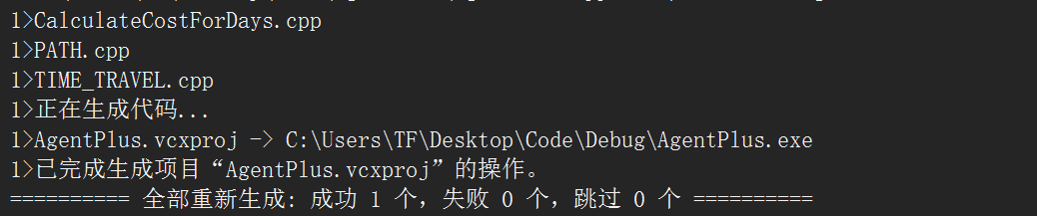

**Figure 7 Find the path of AgentPlus.exe**

1. Method 2

Copy AgentPlus.exe to the folder where input files are located and double-click the .exe file to run the program.

# 5 Input and Output

The following data set uses case1 as an example to describe the input and output data in detail.

## 5.1 Input

1. input_node.csv

As shown in **Table 4**, input_node.csv is the input file of physical nodes information, including: node_id, x, y. node_id is the number of the physical node. x,y are the horizontal and vertical coordinates of nodes and the x,y coordinates of nodes can be used to calculate link length.

**Table 4 input_node.csv**

|  |  |  |
| --- | --- | --- |
| node_id | x | y |
| 1 | 61.671 | 71.431 |
| 2 | 60.451 | 70.882 |
| 3 | 62.22 | 69.113 |
| 4 | 60.939 | 68.198 |
| 5 | 62.83 | 66.063 |
| 6 | 58.194 | 69.967 |

1. input_link.csv

As shown in **Table 5**, input_link.csv is the input file of physical link information. The main content included are:

a. from_node_id: original of the link;

b. to_node_id: destination of link;

c. direction: direction of link. 1 is the positive direction (from_node→to_node), -1 is the reverse direction (to_node→from_node);

d. travel_time_1: link travel time of day1;

e. travel_time_2: link travel time of day2;

The remaining parameters include: speed_limit_in_mph, number_of_lanes, lane_capacity_in_vhc_per_hour, jam_density. This program has not been considered, and users can expand according to actual needs.

1. input_agent.csv

As shown in **Table 6**, input_agent.csv takes passengers and vehicles information as inputs.

a. agent_id: the number of passenger/vehicle (numbered separately);

b. agent_type: 0 means passenger, 1 means vehicle;

c. from_node_id, to_node_id: original and destination;

d. departure_time_start, departure_time_window: earliest departure time and length of time window;

e. arrival_time_start, arrival_time_window: the earliest arrival time and length of time window;

f. capacity: vehicle capacity;

g. base_profit: the initial price of passengers;

Other parameters include VOIVTT_per_hour and VOWT_per_hour. Due to this program has not yet considered, users can expand according to actual needs.

**Table 5 input_link.csv**

|  |  |  |  |  |
| --- | --- | --- | --- | --- |
| from_node_id | to_node_id | direction | travel_time_1 | travel_time_2 |
| 1 | 2 | 1 | 2 | 2 |
| 1 | 3 | 1 | 2 | 2 |
| 1 | 5 | 1 | 1 | 1 |
| 2 | 1 | 1 | 2 | 2 |
| 2 | 4 | 1 | 2 | 2 |
| 2 | 5 | 1 | 1 | 1 |
| 3 | 1 | 1 | 2 | 2 |
| 3 | 4 | 1 | 2 | 2 |
| 4 | 2 | 1 | 2 | 2 |
| 4 | 3 | 1 | 2 | 2 |
| 5 | 6 | 1 | 1 | 1 |
| 6 | 3 | 1 | 1 | **6** |
| 6 | 4 | 1 | 1 | 1 |

**Table 6 input_agent.csv**

|  |  |  |  |  |  |  |  |  |  |
| --- | --- | --- | --- | --- | --- | --- | --- | --- | --- |
| agent_id | agent_type | from_node_id | to_node_id | departure_time_start | departure_time_window | arrival_time_start | arrival_time_ window | capacity | base_profit |
| 1 | 0 | 2 | 6 | 5 | 2 | 9 | 3 |  | 6 |
| 2 | 0 | 5 | 3 | 8 | 2 | 14 | 5 |  | 6 |
| 1 | 1 | 4 | 1 | 1 | 29 | 1 | 29 | 2 |  |

Through inputting the above three files, the program can construct a virtual network including virtual nodes and virtual arcs, as shown in **Figure 8** below.

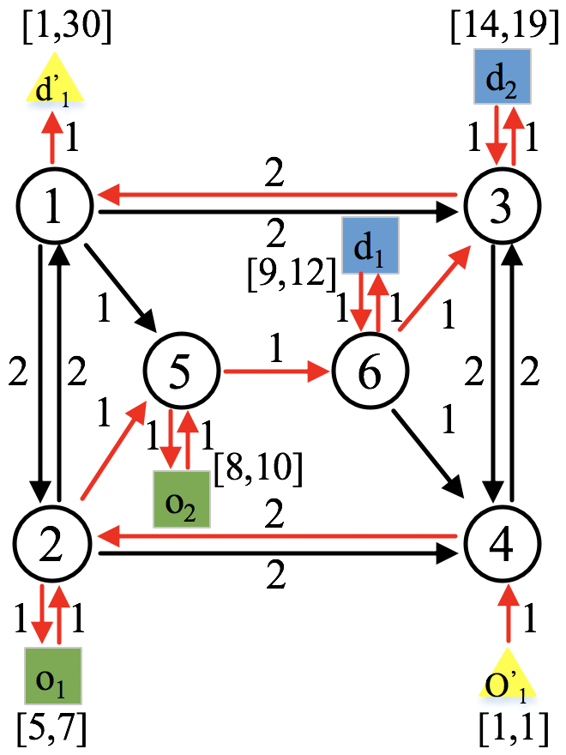 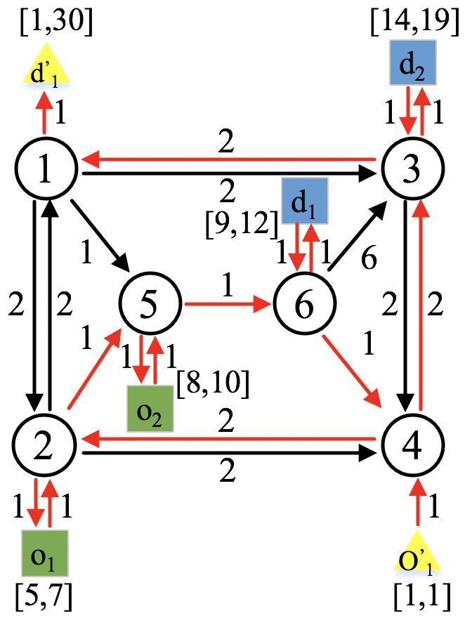

(a) $d=1$ (b) $d=2$

Figure 8 Virtual network of case1

## 5.2 Output

1. output_node.csv

According to the input_node.csv and input_agent.csv files, the program adds virtual nodes: passenger pickup and delivery nodes and vehicle station nodes.

a. node_id: node number. The numbering sequence is physical node, passenger 1 pickup node, passenger 1 delivery node, passenger 2 pickup node, passenger 2 delivery node,..., vehicle departure node, vehicle arrival node.

b. node_type: node attribute. 0 represents the physical node, 1 represents the passenger pickup node, 2 represents the passenger delivery node, and 3 represents the departure and arrival node of the vehicle.

According to the previous input data, we get output_node.csv, as shown in **Table 7**. Among node_id, 1-6 are physical nodes; 7-8 are pickup and delivery nodes of passenger 1, corresponding to $o_{1}$ and $d_{1}$ in **Figure 8**; and 9-10 are pickup and delivery nodes of passenger 2, corresponding to $o_{2}$ and $d_{2}$; 11-12 correspond to $o_{1}^{'}$ and $d_{1}^{'}$.

1. output_link.csv

In the same way, in addition to the existing physical input links, the program will construct virtual arcs based on input_link.csv and input_agent.csv, and output the output_link.csv file shown in **Table 8**.

a. from_node_id and to_node_id: respectively represent the starting and ending point of arc.

b. link_type: 0 represents the physical arc, 1 represents the pickup arc of passenger 1, which is the arc from node 2 to $o_{1}$ in **Figure 8**, and -1 represents the delivery arc of passenger 1, which is the arc from node 3 to $d_{1}$. In the same way, the arcs with attributes 2 and -2 represent pickup and delivery arcs of passenger 2, respectively. 100 represents a vehicle departure arc, which is the arc from $o_{1}^{'}$ to node 4, and 101 represents a vehicle return arc, which is the arc from node 1 to $d_{1}^{'}$.

Note: The program sets the travel time of virtual arcs to 1, which can be modified as required.

**Table 7 output_node.csv**

|  |  |
| --- | --- |
| node_id | node_type |
| 1 | 0 |
| 2 | 0 |
| 3 | 0 |
| 4 | 0 |
| 5 | 0 |
| 6 | 0 |
| 7 | 1 |
| 8 | 2 |
| 9 | 1 |
| 10 | 2 |
| 11 | 3 |
| 12 | 3 |

**Table 8 output_link.csv**

|  |  |  |
| --- | --- | --- |
| from_node_id | to_node_id | link_type |
| 1 | 2 | 0 |
| 1 | 3 | 0 |
| 1 | 5 | 0 |
| 2 | 1 | 0 |
| 2 | 4 | 0 |
| 2 | 5 | 0 |
| 3 | 1 | 0 |
| 3 | 4 | 0 |
| 4 | 2 | 0 |
| 4 | 3 | 0 |
| 5 | 6 | 0 |
| 6 | 3 | 0 |
| 6 | 4 | 0 |
| 2 | 7 | 1 |
| 7 | 2 | 1 |
| 6 | 8 | -1 |
| 8 | 6 | -1 |
| 5 | 9 | 2 |
| 9 | 5 | 2 |
| 3 | 10 | -2 |
| 10 | 3 | -2 |
| 11 | 4 | 100 |
| 1 | 12 | 101 |

1. output_agent.csv

output_agent.csv outputs the shortest time-space path of two days (d=1,2), respectively, after iteration, as shown in **Table 9**.

LR_iteration: Lagrangian algorithm iteration number;

Stepsize: iteration step size;

path_node_seq: node sequence of vehicle travel path;

path_time_seq: the time when the vehicle reaches each node in the path;

Upper bound: the calculation result of upper bound

1. output_paxprofitLog.csv

As shown in **Table 10**, output_paxprofitLog.csv outputs the passenger profit corresponding to each iteration.

1. output_solution.csv

As shown in **Table 11**, output_solution.csv outputs the number of nodes, links, passengers, vehicles contained in case1 and CPU running time. It also includes the cost corresponding to the shortest path per day (d=1,2). For example, the cost of the shortest path for the first day(d=1) is 17, and the cost of the shortest path for the second day(d=2) is 19. their gap value and relative gap also are outputted.

**Table 9 output_agent.csv**

|  |  |  |  |
| --- | --- | --- | --- |
| LR_iteration | Stepsize | path_node_seq | path_time_seq |
| 0 | 1.000000 | 11;4;2;1;12 | 1;2;4;6;7 |
| Upper bound |  | 11;4;2;7;2;5;9;5;6;8;6;3;10;3;1;12; | 1;2;4;5;6;7;8;9;10;11;12;13;14;15;17;18; |
| LR_iteration | Stepsize | path_node_seq | path_time_seq |
| 0 | 1.000000 | 11;4;2;1;12 | 1;2;4;6;7 |
| Upper bound |  | 11;4;2;7;2;5;9;5;6;8;6;4;3;10;3;1;12; | 1;2;4;5;6;7;8;9;10;11;12;13;15;16;17;19;20; |

**Table 10** **output_paxprofitLog.csv**

|  |  |  |  |  |  |  |  |  |  |  |  |  |
| --- | --- | --- | --- | --- | --- | --- | --- | --- | --- | --- | --- | --- |
| iteration | Stepsize | p1's profit | p2's profit | p3's profit | p4's profit | p5's profit | p6's profit | p7's profit | p8's profit | p9's profit | p10's profit | LowerBoundCost |
| 0 | 1 | 6 | 6 | 0 | 0 | 0 | 0 | 0 | 0 | 0 | 0 | 18 |

**Table 11 output_solution.csv**

|  |  |  |  |  |  |  |
| --- | --- | --- | --- | --- | --- | --- |
| number of nodes= | 6 |  |  |  |  |  |
| number of links= | 13 |  |  |  |  |  |
| number of passengers= | 2 |  |  |  |  |  |
| number of vehicles= | 1 |  |  |  |  |  |
| 18.000000 | 17.000000 | -1.000000 | -5.882% | CPU Running Time= | 307 | milliseconds |
| number of nodes= | 6 |  |  |  |  |  |
| number of links= | 13 |  |  |  |  |  |
| number of passengers= | 2 |  |  |  |  |  |
| number of vehicles= | 1 |  |  |  |  |  |
| 18.000000 | 19.000000 | 1.000000 | 5.263% | CPU Running Time= | 238 | milliseconds |

1. Debug.txt

Debug.txt is shown in **Figure 9**. The file outputs the following information in turn:

a. the number of virtual nodes, the number of virtual links, the number of passengers and the number of vehicles;

b. virtual links and corresponding link_type,

c. The original and destination of the vehicle, as well as the updated information in the LR and DP calculations.

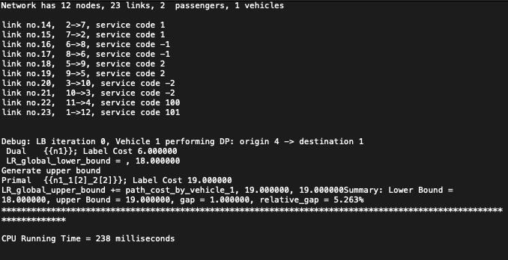

**Figure 9 Debug.txt**

# 6 Tests

The test data set is stored in the dataset folder, and case1-4 correspond to:

**Scenario 1** The travel time in the historical data just meets the time window, and no passenger waiting or vehicle waiting behaviour occurs;

**Scenario 2** There are changes in travel time of specific days in the historical data, causing passengers to wait;

**Scenario 3** There are changes in travel time of specific days in the historical data, causing vehicles to wait;

**Scenario 4** There are changes in the travel time of specific days in the historical data, which makes it impossible to meet the time window of some passengers, resulting in passengers not being served.

The physical network remains the same. Input_node.csv is the same as the example of 5.1 section. Change the two columns of travel_time_1 and travel_time_2 in the input_link_csv file according to **Table 12**, and the input_agent.csv file according to **Table 13**. The final results of the four scenarios are shown in **Table 14**.

**Table 12 Travel time of four** **scenarios**

|  |  |  |  |  |  |  |  |  |
| --- | --- | --- | --- | --- | --- | --- | --- | --- |
| link | Scenario 1 | | Scenario 2 | | Scenario 3 | | Scenario 4 | |
| Day1 | Day2 | Day1 | Day2 | Day1 | Day2 | Day1 | Day2 |
| (1,2) | 2 | 2 | 2 | 2 | 2 | 2 | 2 | 2 |
| (1,3) | 2 | 2 | 2 | 2 | 2 | 2 | 2 | 2 |
| (1,5) | 1 | 1 | 1 | 1 | 1 | 1 | 1 | 1 |
| (2,1) | 2 | 2 | 2 | 2 | 2 | 2 | 2 | 2 |
| (2,4) | 2 | 2 | 2 | 2 | 2 | 2 | 2 | 2 |
| (2,5) | 1 | 1 | 1 | **2** | 1 | 1 | 1 | **4** |
| (3,1) | 2 | 2 | 2 | 2 | 2 | 2 | 2 | 2 |
| (3,4) | 2 | 2 | 2 | 2 | 2 | 2 | 2 | 2 |
| (4,2) | 2 | 2 | 2 | 2 | 2 | **1** | 2 | 2 |
| (4,3) | 2 | 2 | 2 | 2 | 2 | 2 | 2 | 2 |
| (5,6) | 1 | 1 | 1 | 1 | 1 | 1 | 1 | 1 |
| (6,3) | 1 | **6** | 1 | 1 | 1 | 1 | 1 | 1 |
| (6,4) | 1 | 1 | 1 | 1 | 1 | 1 | 1 | 1 |
| (2, $o_{1}$) | 1 | 1 | 1 | 1 | 1 | 1 | 1 | 1 |
| ($o_{1}$,2) | 1 | 1 | 1 | 1 | 1 | 1 | 1 | 1 |
| (6, $d_{1}$) | 1 | 1 | 1 | 1 | 1 | 1 | 1 | 1 |
| ($d_{1}$,6) | 1 | 1 | 1 | 1 | 1 | 1 | 1 | 1 |
| (5, $o_{2}$) | 1 | 1 | 1 | 1 | 1 | 1 | 1 | 1 |
| ($o_{2}$,5) | 1 | 1 | 1 | 1 | 1 | 1 | 1 | 1 |
| (3, $d_{2}$) | 1 | 1 | 1 | 1 | 1 | 1 | 1 | 1 |
| ($d_{2}$,3) | 1 | 1 | 1 | 1 | 1 | 1 | 1 | 1 |
| ($o_{1}^{'}$,4) | 1 | 1 | 1 | 1 | 1 | 1 | 1 | 1 |
| (1, $d_{1}^{'}$) | 1 | 1 | 1 | 1 | 1 | 1 | 1 | 1 |

**Table 13 Passenger and vehicle information of four scenarios**

|  |  |  |  |  |  |  |  |  |
| --- | --- | --- | --- | --- | --- | --- | --- | --- |
|  | Scenario 1 | | Scenario 2 | | Scenario 3 | | Scenario 4 | |
| Day1 | Day2 | Day1 | Day2 | Day1 | Day2 | Day1 | Day2 |
| the number of passengers | 2 | 2 | 2 | 2 | 2 | 2 | 2 | 2 |
| the number of vehicles | 1 | 1 | 1 | 1 | 1 | 1 | 1 | 1 |
| original of $p_{1}$ | Node 2 | Node 2 | Node 2 | Node 2 | Node 2 | Node 2 | Node 2 | Node 2 |
| destination of $p_{1}$ | Node 6 | Node 6 | Node 6 | Node 6 | Node 6 | Node 6 | Node 6 | Node 6 |
| original of $p_{2}$ | Node 5 | Node 5 | Node 5 | Node 5 | Node 5 | Node 5 | Node 5 | Node 5 |
| destination of $p_{2}$ | Node 3 | Node 3 | Node 3 | Node 3 | Node 3 | Node 3 | Node 3 | Node 3 |
| original of $v_{1}$ | Node 4 | Node 4 | Node 4 | Node 4 | Node 4 | Node 4 | Node 4 | Node 4 |
| destination of $v_{1}$ | Node 1 | Node 1 | Node 1 | Node 1 | Node 1 | Node 1 | Node 1 | Node 1 |
| departure time window of $p_{1}$ | [5,7] | [5,7] | [5,7] | [5,7] | [5,7] | [5,7] | [5,7] | [5,7] |
| arrival time window of $p_{1}$ | [9,12] | [9,12] | [9,12] | [9,12] | [9,12] | [9,12] | [9,13] | [9,13] |
| departure time window of $p_{2}$ | [8,10] | [8,10] | [8,10] | [8,10] | [8,10] | [8,10] | [8,10] | [8,10] |
| arrival time window of $p_{2}$ | [14,19] | [14,19] | [14,19] | [14,19] | [14,19] | [14,19] | [14,19] | [14,19] |
| departure time window of $v_{1}$ | [1,1] | [1,1] | [1,1] | [1,1] | [1,1] | [1,1] | [1,1] | [1,1] |
| arrival time window of $v_{1}$ | [1,30] | [1,30] | [1,30] | [1,30] | [1,30] | [1,30] | [1,30] | [1,30] |

**Table 14 Results of four scenarios**

|  |  |  |  |  |
| --- | --- | --- | --- | --- |
| Iteration | Path_node_seq | Lowerbound | Upperbound | Gap(%) |
| Scenario 1 No passenger waiting or vehicle waiting behavior occurs | | | | |
| 1 | 11,4,2,1,12 | 6 | 19 | 68.42 |
| 2 | 11,4,2,7,2,5,9,5,6,8,6,4,3,10,3,1,12 | 19 | 19 | 0.00 |
| Scenario 2 Passenger waiting | | | | |
| 1 | 11,4,2,1,12 | 6 | 17.65 | 66.01 |
| 2 | 11,4,2,7,2,5,9,5,6,8,6,3,10,3,1,12 | 17.65 | 17.65 | 0.00 |
| Scenario 3 Vehicle waiting | | | | |
| 1 | 11,4,2,1,12 | 6 | 16.75 | 64.18 |
| 2 | 11,4,2,7,2,5,9,5,6,8,6,3,10,3,1,12 | 16.75 | 16.75 | 0.00 |
| Scenario 4 Passenger not being served | | | | |
| 1 | 11,4,2,1,12 | 6 | 19.6 | 68.34 |
| 2 | 11,4,2,7,2,1,5,9,5,6,8,6,3,10,3,1,12 | 19.6 | 19.6 | 0.00 |